



Bopinc

Personal Care Dispenser Manual

Version 1.1
16/08/2023

Contents

Contents 2
1. Background 2
2. Usage 3
3. Dispenser Overview 4
Power supply 4
Measurements and Key Components 5
4. How dispensing works in the backend 5
Dispensing Accuracy 5
Identification, Networking, and Data Collection 8
Product Quality Assurances and Cleaning 8
5. Stock replenishment 9
6. Troubleshooting 10

1. Background
The refill dispenser is an electronic machine that dispenses viscous liquid personal care products such as hand soap and shampoo. Consumers use the machine, located at small neighborhood stores, to refill a reusable plastic container with their favorite personal care products from the dispenser. The objective of the dispenser is to give consumers an affordable alternative to purchasing personal care products in single-use plastic sachets which have become an environmental problem in markets like Bangladesh. The refill machine is designed and manufactured by Wizkit, DYDX, and Bopinc, in consultation with Unilever Bangladesh which will be piloting this innovation at a small number of Dhaka.

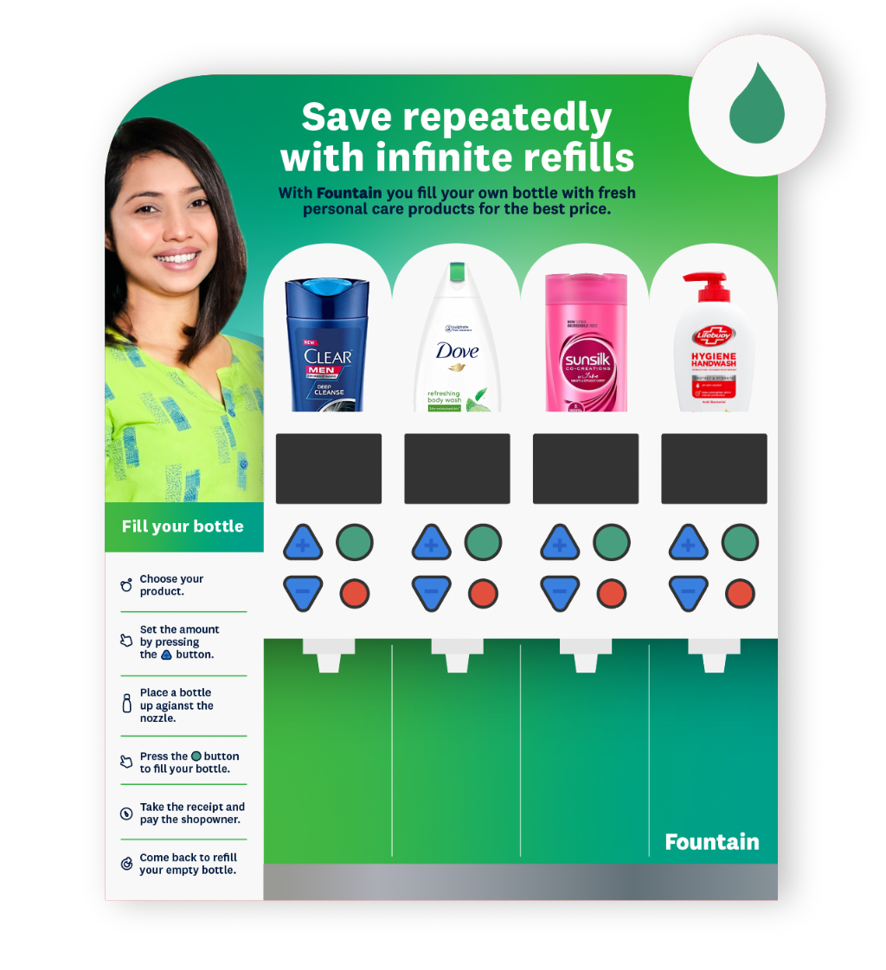
Image: Frontside of the personal care dispenser (in Bangladesh, text on the artwork will be translated to Bengali)

2. Usage
To use the machine, a consumer will bring a reusable, empty plastic container to the store where the dispenser is located. Either the retailer or the user will operate the machine to refill the container with the product of choice. Consumers get a printed receipt and pay the retailer, after which they take the bottle, use the product at home, and wash the bottle once it is empty and needs to be refilled again.

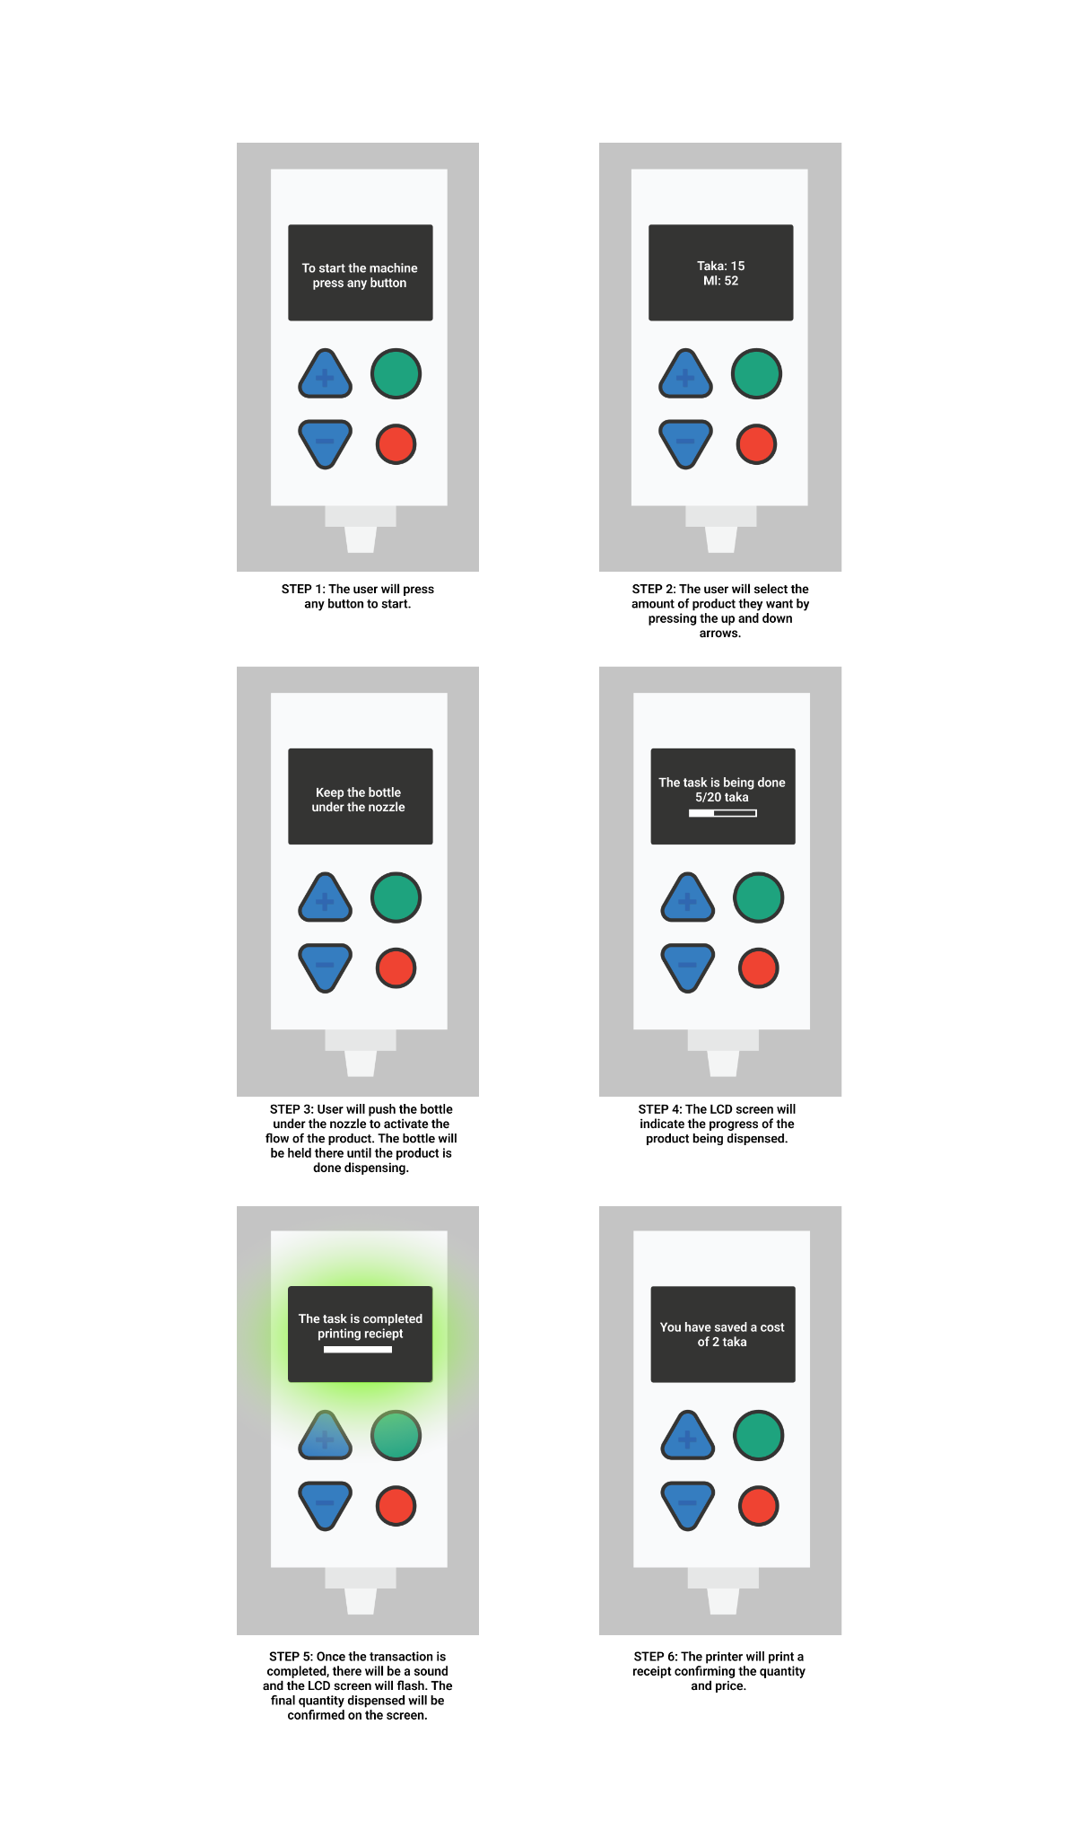

3. Dispenser Overview

Power supply
Grid power is required for the electronic refill dispenser to operate. There is no on/off switch for the dispenser; it automatically turns on once connected to a power supply and off when there is no power supply. The machine is indicated as being on when the LCD screens show text and light are lit up. Additionally the machine will make a distinct buzzer sound when the machine is initialized and ready to dispense.

The dispenser has a standard power cable and a plug that plugs into the main grid electricity supply. In the case of brief periods of power blackouts, the battery inside the machine can continue to power the dispenser for up to 4 hours of continual motor use. The battery is recharged when the main power supply is back on.

Electric connection

The machine works at a Maximum of 12V, 5 A and can be plugged into a normal electricity plug point. Maximum power output is 60W.

The machine operates at less than half of its specified wattage so the actual power consumption is around 0.03 Wh
Everyday cost for the machine's electricity will be around 4 Taka (considering 10 hours of shop open time and unit price as 9.5 Taka).

Battery
The battery is 7Ah battery which can provide a maximum backup of 84Wh which would result in about 4-5 hours of backup power

Measurements and Key Components
Front view
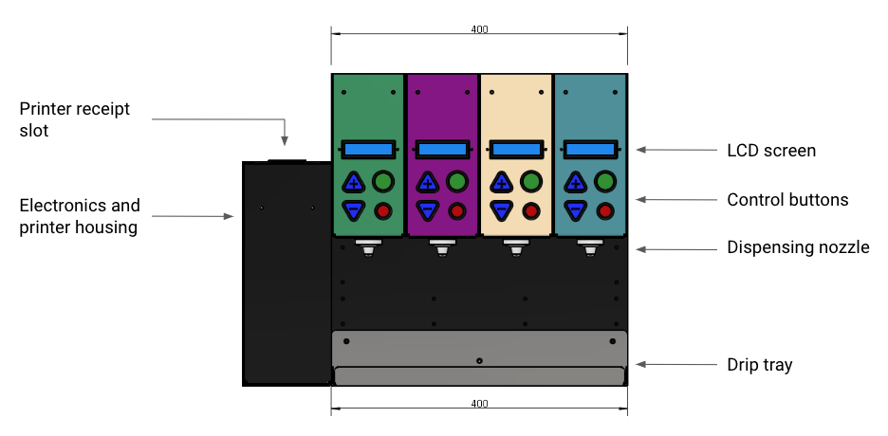

Side view
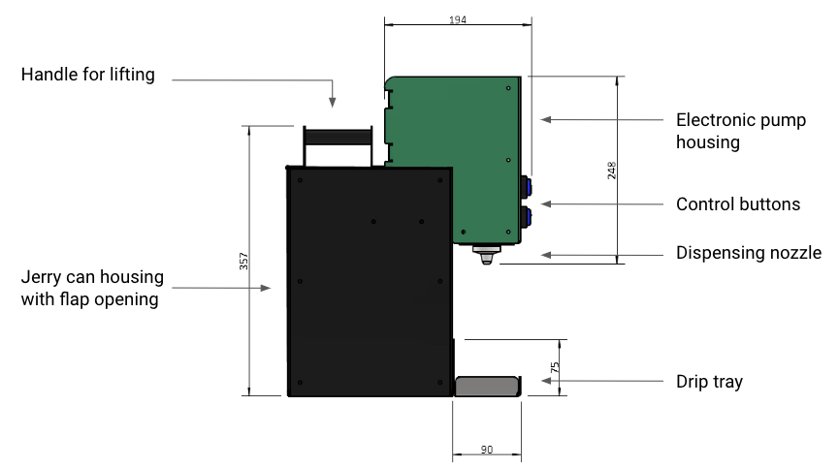

Internal view
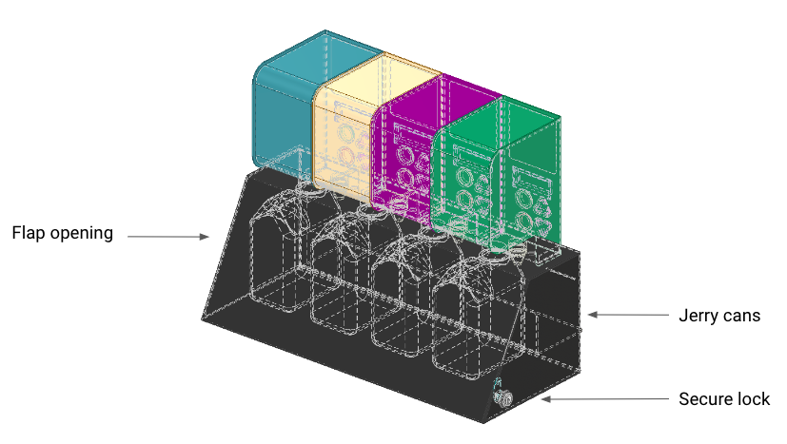

4. How dispensing works in the backend
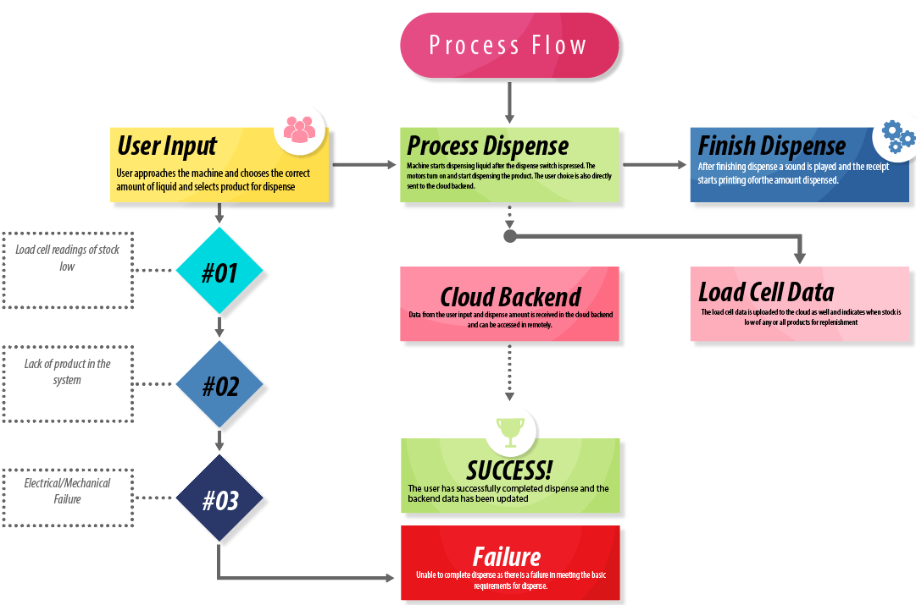

Dispensing Accuracy
The dispenser provides three options of volume for the user to choose. The options reflect low, medium and high values where the medium value generally represents the most commonly dispensed amount. Error margin of the dispenser is between an under dispense of 3% to an over dispense of maximum 10% . Any error is designed generally tol be advantageous for the consumer, meaning they get a bit more than the quantity they select provided external factors do not greatly affect the integrity of the fluids in the machine.

The machine uses 4 peristaltic pumps rated at 12V, 500ml/min controlled by a precise L298N motor driver to dispense accurate amounts of fluid. Fluid accuracy is ensured during the initial calibration of the machine which runs the specific liquids multiple times through the system until the system is calibrated to dispense exactly or slightly more than the requested amount by the user. Each product segment hosts a separate motorized unit and each product category is individually calibrated to dispense the correct amount.

Calibration Methods:

- Dispense Calibration
To calibrate for dispensing the motor is run for a predetermined set amount of time after priming to check how much liquid is dispensed using a graduated cylinder/beaker. Once the relationship with timing and amount dispensed is established the dispensing factor inside the microcontroller of the machine is set to always dispense accurate amounts of fluid. These motors are industrially used as dosing pumps and therefore are known for high levels of accuracy which does not waiver over time.
- Load-Cell Calibration
A known load is placed on the holder which is mounted to the load cell. The known weight is used to calibrate the sensor and then that calibration factor is uploaded to the microcontroller through code using a computer. The load cell mainly helps to report low stock and allows it to stop dispensing when stock is below a threshold value as per what is set in the system.

Identification, Networking, and Data Collection
Every machine is connected to the internet via a unique sim-card and machine ID. This allows the creators to identify and track each machine by its geographical location, network timing, connectivity, and also by its unique ID (a personalized number for each machine). When a machine is first set up in a specific location, the machine is initialized by our technical team to connect it to the cloud services. Once connected, the machine can report forms of machine usage data to the cloud server. Data includes number of user interaction per day, dispensing amount, time of dispensing, and machine downtime. The machine does not collect data specific to individual customers, meaning all data is anonymous. The data that is captured is solely used for the purpose of monitoring and evaluation of how the machines perform.

Product Quality Assurances and Cleaning
Quality of the personal care products dispensed is maintained in 4 ways:
- Suppliers restock the machines using jerry cans that are securely contained within the dispenser itself. Access to the jerry cans is protected by lock and key. Only approved Unilever brand representatives have a key and are able to gain access to the jerry cans to protect the product from being tampered with.
- Jerry cans are not exposed to UV as they are secured within the dispenser.
- To avoid any microbial contamination or degradation of the product itself, the dispenser can only dispense the product from the jerry cans, the product cannot be reversed back into the machine or jerry cans.
- To minimize product contact with air as well as unintentional dripping of the product, the dispenser nozzle contains a sealed closure that shuts when the machine stops dispensing.
- The nozzle of the machine can be wiped clean using a damp cloth, possibly with ethanol. This is important because consumers will touch the nozzle with their refill container.

Cleaning
Regular and frequent cleaning of the nozzles is recommended to stop buildup around the nozzles. This can be achieved by using isopropyl alcohol or ethanol and a disposable tissue/paper tower to clean the nozzle head.

Deeper cleaning must only be carried out by authorized Unilever restocking personnel where a standard cleaning process must be followed:
- Unplug the machine and remove the tubing from the jerry cans carefully.
- Clean the exterior of the tubing with isopropyl alcohol/ethanol
- Turn the machine on and connect the tubing to isopropyl alcohol/ethanol containers
- Dispense the liquid using the regular machine function until the liquid starts coming out from the nozzle. Once the liquid has come out from the nozzle stop dispensing on that unit and repeat for all 4 units within one machine.
- Use a cotton bar or fiber cloth to clean the nozzle head with alcohol/ethanol.
- Use distilled water to clear out any excess alcohol/ethanol from the system to avoid any other contamination.
- Replenish product jerry cans and put the tubing inside the product jerry cans (make sure the tubing does not touch other parts of the machine during the process after cleaning.)
- Close and lock the access door of the machine.

5. Stock replenishment
Unilever brand representatives are responsible for replenishing empty jerry cans and will have a key to unlock the refill dispenser to gain access to replenish jerry cans. Product stock levels are monitored via cloud software where weekly stock and usage reports will be circulated with Bopinc and Wizkit. The software will flag Jerry cans with low stock levels, and teams can notify Unilever to order and facilitate replenishment of that machine and product.

The process to replenish empty jerry cans is as follows:
- Authorized persons to unlock the dispenser by opening it with a key and lifting the back flap to gain access to the jerry cans.
- Unscrew the lid of the jerry cans and take the jerry cans out of the dispenser housing.
- Clean the tube and the nozzle of the product that is being replenished as per the requirements described in section 4.
- Remove the lid of the new, full jerry can and place the dispenser tube into the new jerry can, and screw the attached cap.
- Place the jerry cans securely within the dispenser housing.
- Close the housing flap and lock it with a key.

6. Troubleshooting
If the dispenser stops working, the retailer can notify Unilever who will contact their technical partner, Wizkit, to troubleshoot the machine on-site. The machine can be replaced with a backup machine if any issues cannot be immediately resolved, and the broken dispenser can be repaired as needed offsite.

Common Troubleshooting Scenarios:

Problems | Primary Actions | Secondary Actions | Advanced Diagnosis
Printer not printing | Check if the printer is on and the blue light on the printer is on. | Hold the power button to restart the printer | - Printer battery failure  - Paper run out  - Printer malfunction  - Communication problem with communication ESP
Printer not printing | Check printer paper | Reload Printer Paper and restart the printer using the power button
Displays not turned on | Check main power line | Restart device. And Re-seat the power plug and check if the display comes on. | - Wiring fault  - LCD damage  - Voltage issues  - Damaged microcontrollers  - Power supply fault
Displays not turned on | Hear to check sound feedback | Restart the device. If there is sound feedback but no display report immediately.
Buttons not working | Restart the device. | Restart using a different power outlet, and check to see if that specific power outlet has grounded. | - Grounding problem  - Wiring fault
Random characters on screen | Restart device. | Make sure the device is on a stable surface and not moving or jerking constantly. | - Wiring Problem  - Microcontroller damage
Uneven dispensing | Clean pipes and nozzle | Run a cleaning solution through the dispense delivery system. | - Nozzle clog  - Silicone pipe damage
Premature stop while dispensing | Check product stock | Check for clogs. Run a cleaning solution through the system. | - Motor driver  - Motor  - Low stock  - Microcontroller damage

